ISSN (Print): 2394-5443 ISSN (Online): 2394-7454
Research Article
http://dx.doi.org/10.19101/IJATEE.2025.121220005

Energy dissipation mechanisms in reinforced concrete shear walls under seismic loading
Yasir W. Abduljaleel*, Ali S. Ali and Zainab A. Mohammed
Department of Civil Engineering, Al-Iraqia University, Baghdad, Iraq

Received: 02-January-2025; Revised: 24-July-2025; Accepted: 26-July-2025
©2025 Yasir W. Abduljaleel et al. This is an open access article distributed under the Creative Commons Attribution (CC BY) License, which permits unrestricted use, distribution, and reproduction in any medium, provided the original work is properly cited.
Abstract
Reinforced concrete shear walls (RCSWs) are essential structural components for dissipating seismic energy in buildings. This study investigates the energy dissipation mechanisms of RCSWs under seismic loading by analyzing the effects of wall height-to-width ratio, concrete compressive strength, and reinforcement ratio. Twenty-four RCSW models with varying parameters were analyzed using the finite element method (FEM) in CSI-SAP2000. The models were evaluated based on energy dissipation, displacement, and drift responses. Results show that increasing wall width like reducing the height-to-width ratio enhanced energy dissipation by up to 66%, while also increasing stiffness and reducing displacement. When the compressive strength was increased from 25 MPa to 35 MPa, energy dissipation improved by 33.27%, 54.55%, and 66%, attributed to the corresponding increase in the modulus of elasticity. In contrast, higher reinforcement ratios, while improving structural ductility, led to a reduction in energy dissipation ranging from 1.82% to 19.79%. This study provides quantitative correlations between key design parameters and seismic performance metrics, offering practical guidelines for optimizing RCSW designs in earthquake-prone regions.

Keywords
Energy dissipation, Static/dynamic analysis, Reinforced concrete, Seismic loading, Finite element method, CSI-SAP2000.

Introduction
Reinforced concrete shear walls (RCSWs) are essential lateral force-resisting structural systems widely employed in seismic- prone regions to enhance building resilience [1, 2]. These walls serve as primary energy dissipation elements, absorbing and dissipating seismic energy through controlled deformation mechanisms [3, 4]. Recent advancements in seismic design methodologies have emphasized quantifying energy dissipation capacity as a key performance indicator for structural resilience and safety [5, 6]. The seismic response of RCSWs is governed by complex interactions between geometric parameters, material properties, and reinforcement configurations [7, 8]. Contemporary research has demonstrated that strategic optimization of these parameters can significantly enhance energy absorption capacity and minimize structural damage during earthquakes [9, 10].

*Author for correspondence
The emergence of innovative composite materials and hybrid reinforcement systems has further expanded the potential for improving the seismic performance of reinforced concrete (RC) shear walls [11, 12]. Despite substantial research progress, significant challenges persist in quantifying and optimizing energy dissipation mechanisms in RC shear walls. The complex interactions between wall geometry, material properties, and reinforcement patterns remain inadequately addressed in current design codes [13, 14]. Another critical challenge is predicting how variations in height-to-width ratios affect energy dissipation capacity under different loading conditions [15, 16]. Additionally, while increasing concrete compressive strength generally improves structural performance, its specific correlation with energy dissipation requires further investigation [17, 18]. Furthermore, the seemingly contradictory effects of reinforcement ratios on ductility versus energy dissipation capacity necessitate a more comprehensive understanding [19, 20].

This study aimed to comprehensively evaluate the energy dissipation mechanisms in RC shear walls under seismic loading through finite element analysis. The effects of the wall height-to-width ratio, concrete compressive strength, and reinforcement ratio on energy dissipation capacity, displacement response, and base shear resistance are investigated. The research seeks to establish quantitative relationships between these parameters to inform more resilient structural design approaches.
The primary contributions of this research include:
(1) quantitative assessment of energy dissipation improvements (up to 66%) achieved through optimized wall width configurations; (2) demonstration of the proportional relationship between concrete compressive strength and energy dissipation capacity; (3) evidence that increased reinforcement ratios, while enhancing ductility, can reduce energy dissipation by up to 22%; and (4) development of detailed performance criteria for RC shear walls based on integrated analysis of static and dynamic loading conditions. These findings provide practical design insights for enhancing seismic resilience in RC structures.

The remainder of this paper is organized as follows: Section 2 presents a review of recent literature on RC wall seismic performance; Section 3 describes the research methodology and finite element modeling approach; Section 4 presents results and analysis; Section 5 provides discussion of findings; and Section 6 offers conclusions and recommendations for future research.

Literature review
Recent investigations by Hosseini et al. [2] and Cheng et al. [3] have explored innovative materials
and hybrid systems, including hybrid steel–glass fiber reinforced polymer (GFRP) reinforcement and optimized steel plate integration. These approaches demonstrate significant improvements in lateral stiffness, energy dissipation, and deformation capacity, although implementation challenges include increased cost and design complexity. Case-specific research has also gained prominence, with studies by Uroš et al. [4], Shi et al. [9], and Alarcón et al. [6] analyzing the seismic performance of specific building types and geographical locations. Li et al.
- developed a comprehensive framework for predicting the seismic response of RC walls under dynamic loads, emphasizing the necessity of experimental calibration. Zhao et al. [8] investigated the use of carbon fiber reinforced polymer (CFRP) as reinforcement, demonstrating enhanced energy dissipation and reduced residual deformations. A recurring theme in contemporary research is the influence of material selection and structural configuration. Studies by De and Pecce [11] and Laissy [5] examined the effects of masonry infills, construction techniques, and reinforcement configurations on seismic performance. These works demonstrate how complex architectural configurations enhance stability and adaptability while addressing challenges such as structural irregularity. El-azizy et al. [16] provided valuable insights into balancing cost considerations against performance in their economic evaluation of architectural solutions involving RC and masonry walls. The application of numerical and computational modeling has emerged as a crucial approach for seismic response interpretation. Gürbüz and Kazaz [20] employed machine learning techniques to predict seismic characteristics with high accuracy (R² = 0.94). The key study advantages and limitations is shown in Table 1.

Table 1 Key RC shear wall studies (2020-2024)
Study | Focus | Advantages |  |  | Limitations
[3] | Multi-dimensional seismic loading | Enhanced dissipation | stiffness | and energy | High cost and complex design
  - Cyclic and axial loads Insights into energy dissipation Limited to rectangular cross-
sections

  - Reinforcement configurations Double-layer walls show 30% better
strength
Increased cost and complexity

- Wall size effects Refined deformation limits Limited experimental validation

[2] Hybrid-reinforced RC walls Improved ductility and energy
dissipation
Limited scalability

- CFRP retrofitting Increased flexural and shear capacities High material costs

- Curved walls under cyclic loading Stable hysteretic response Lack of design code
recommendations

- Performance and economic assessment
Higher ductility and reduced costs Limited application scope

These computational methods provide engineers with robust decision-making tools but require extensive datasets and specialized expertise. Recent studies [25– 29] have increasingly focused on incorporating material degradation effects and dynamic impacts into seismic performance models. These studies provide valuable insights but highlight challenges in extrapolating results across diverse scenarios. While significant progress has been made in understanding and enhancing seismic performance of RC shear walls, important gaps remain in areas such as cost optimization, experimental validation, and practical implementation of advanced computational techniques. Our research addresses several of these gaps by providing a comprehensive parametric analysis of key design variables affecting energy dissipation in RC shear walls.
steel yielding. These elements, based on composite material mechanics principles, allow for different mechanical properties in each layer. The mesh size was determined through a mesh convergence study, with final element dimensions of 0.25m × 0.25m selected as optimal after comparing results with mesh sizes ranging from 0.1m to 0.5m. The convergence criterion was set at less than 2% difference in maximum displacement and energy dissipation values.
Material Constitutive Models
The Takeda hysteretic model was implemented to capture the nonlinear stress-strain behavior of concrete. This model is expressed mathematically in Equations 1 and 2.
F = K₀ ⋅ δ for δ ≤ δy (1)

δ 𝝰
F = Fy ⋅ ()
for δ > δy (2)

Methods

Experimental design
This study employed a parametric investigation approach to evaluate the energy dissipation mechanisms in RCSWs under seismic loading. Twenty-four RCSW models were designed with systematic variations in three key parameters: wall height-to-width ratio (ranging from 0.5 to 1.0), concrete compressive strength (25, 30, and 35 MPa), and reinforcement ratio (varied through rebar spacing of 1.5m and 2.0m center-to-center). The factorial design allowed for isolation and quantification of the effects of each parameter on energy dissipation characteristics.

Finite element modelling (FEM) Model development and validation
The FEM was implemented using CSI-SAP2000 (version 20) [26], a commercial structural analysis software widely validated for nonlinear seismic
δy

where F is the force, K₀ is the initial stiffness, δ is the displacement, δy is the yield displacement, Fy is the yield force, and α is the stiffness degradation parameter (set to 0.3 based on calibration).The concrete cracking model incorporates tension stiffening effects, with a tension-softening curve defined by Equation 3.
σt = ft ⋅ e^{−𝝰⋅𝝴} (3)

where σt is the tensile stress, ft is the tensile strength, ε is the strain, and α is a material parameter set to 500 for normal-weight concrete.

Steel reinforcement was modeled using an elasto- plastic model with strain hardening, defined as Equation 4.
Es ⋅ εs forεs ≤ εy
⎛

analysis. The FEM models were validated against
σs =
fy + Esh ⋅ (εs − εy) forεy < εs ≤ εu
(4)

published experimental benchmarks from Bastami et al. [18] and Ghaseminia et al. [19], showing
⎨fu
⋅ (1 − 𝝴s−𝝴𝖚) forε
𝝴𝐹−𝝴𝖚 u
< εs
≤ εf

correlation coefficients above 0.92 for force- displacement relationships and energy dissipation values. The computational analysis was performed on a high-performance workstation with Intel Xeon E5- 2690 processors (2.9 GHz, 12 cores) and 64 GB RAM, with typical solution times ranging from 4 to 6 hours per model.
{

Element selection and mesh properties
Multi-layered shell elements (Shell- Layered/Nonlinear type) were used to model the RCSWs, enabling accurate representation of through- thickness behavior including concrete cracking and
where Es is the elastic modulus (200 GPa), Esh is the strain hardening modulus (10 GPa), εy is the yield strain, εu is the ultimate strain, εf is the fracture strain, fy is the yield strength (413 MPa), and fu is the ultimate strength (620 MPa).

Loading and boundary conditions Modal properties and damping
A modal analysis was performed for each model to determine fundamental periods, which ranged from 0.18s to 0.42s depending on wall configuration. The first mode shapes predominantly exhibited flexural

deformation for high aspect ratio walls (height-to- width (H/W) = 1.0) and combined flexural-shear deformation for lower aspect ratios. Rayleigh damping was applied with 5% critical damping for the first and third modes.

Seismic loading protocol
The seismic analysis incorporated both static and dynamic approaches:
- Linear static analysis: Base shear forces were calculated according to the Iraq Seismic Code with a seismic zone factor of 0.3g, importance factor of 1.0, and response modification factor of 5.0. Lateral loads were applied at floor diaphragm levels with an inverted triangular distribution.
- Nonlinear time history analysis (NLTHA): Ground motion records were selected and scaled to match the design response spectrum per American
Comparative analysis between different model parameters was performed using normalized indices to enable direct comparison. Statistical significance was evaluated using analysis of variance (ANOVA) with p < 0.05 considered significant.

Results

Modal analysis results
Table 2 presents the fundamental periods and mass participation factors for selected models. As expected, the fundamental period decreased with increasing wall width (decreasing H/W ratio) and increasing concrete strength, indicating higher structural stiffness. Models with higher reinforcement ratios showed slightly lower periods due to increased stiffness contribution from the reinforcement.

Table 2 Modal analysis results for selected models

Society of Civil Engineers (ASCE) 7-16 [28]. The
integration time step was set at 0.01s with a
Model H/W Ratio Period
(s)
Mass participation (%)

maximum of 3,000 steps. The Newmark-Beta method with parameters = 0.25 and = 0.5 was used for numerical integration.
- Nonlinear static (Pushover) analysis: Displacement-controlled loading was applied incrementally until target displacement or strength degradation of 20% was reached. The convergence tolerance was set at 0.001 for force and displacement criteria.

Data analysis methods
Energy dissipation was calculated by integrating the force-displacement hysteresis loops using the trapezoidal rule (Equation 5):
E = ∮ F ⋅ dδ = ∑^{n−1} 1 (F + F )(δ − δ )
W01 1.00 0.42 76.3
W04 0.50 0.21 83.2
W09 1.00 0.39 77.5
W012 0.50 0.18 85.1

Displacement and drift responses
Figure 1 illustrates the displacement profiles along the height of walls with different H/W ratios. The displacement was consistently highest at the top of the walls, with magnitudes decreasing as wall width increased. For model W01 (H/W = 1.0), the maximum displacement reached 39.22 mm, while model W04 (H/W = 0.5) exhibited only 9.68 mm displacement, representing a 75.3% reduction. This significant decrease demonstrates the substantial

D i=1 2 i
i+1
i+1 i
(5)
impact of wall width on lateral stiffness and displacement control.

where Fi is the base shear force and δi is the corresponding displacement at time step i.
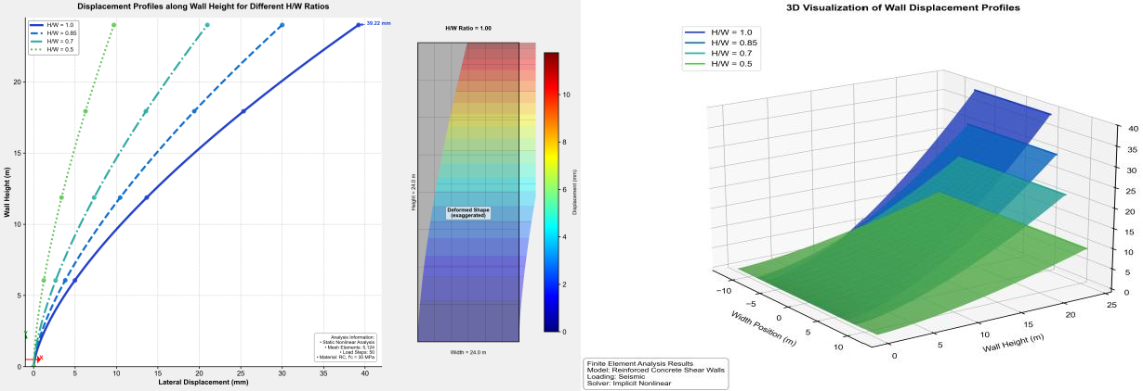
Figure 1 Displacement profiles along wall height for models with different H/W ratios

Table 3 presents comprehensive results for base shear, displacement, and drift for all models. The drift ratios followed similar trends to displacements, with values ranging from 0.00040 to 0.00290, all within acceptable limits per ACI 318-19. Models with higher compressive strength consistently showed lower displacements for the same H/W ratio, confirming the positive impact of increased concrete strength on structural stiffness. Hysteretic Behavior and Energy Dissipation
Table 3 Base shear, displacement, and drift results
Figure 2 shows representative hysteresis loops for models with different H/W ratios. The enclosed area within these loops represents the energy dissipated during seismic loading. Models with higher H/W ratios (e.g., W01, H/W = 1.0) exhibited wider hysteresis loops, indicating greater energy dissipation capacity but also larger displacements. Conversely, models with lower H/W ratios (e.g., W04, H/W = 0.5) showed narrower loops with higher peak forces, demonstrating greater strength but reduced energy dissipation.

Model | Base Shear (kN) | Drift | Displacement (mm) | Time (s)
W01 | 248.10 | -0.00164 | -39.22 | 2.49
W02 | 300.18 | -0.00153 | -36.38 | 2.29
W03 | 434.65 | -0.00087 | -20.97 | 1.78
W04 | 508.57 | -0.00040 | -9.68 | 2.74
W05 | 249.65 | -0.00200 | -48.01 | 2.47
W06 | 384.58 | -0.00150 | -36.02 | 2.27
W07 | 500.42 | -0.00126 | -30.40 | 2.56
W08 | 546.36 | -0.00048 | -11.54 | 5.05
W09 | 275.04 | -0.00214 | -48.86 | 2.46
W010 | 436.00 | -0.00159 | -41.56 | 2.27
W011 | 598.20 | -0.00120 | -28.81 | 2.56
W012 | 623.54 | -0.00080 | -20.01 | 3.63
W013 | 201.61 | -0.00225 | -52.60 | 2.60
W014 | 283.82 | -0.00077 | -18.58 | 2.24
W015 | 420.75 | -0.00125 | -26.60 | 2.57
W016 | 499.35 | -0.00038 | -9.12 | 2.75
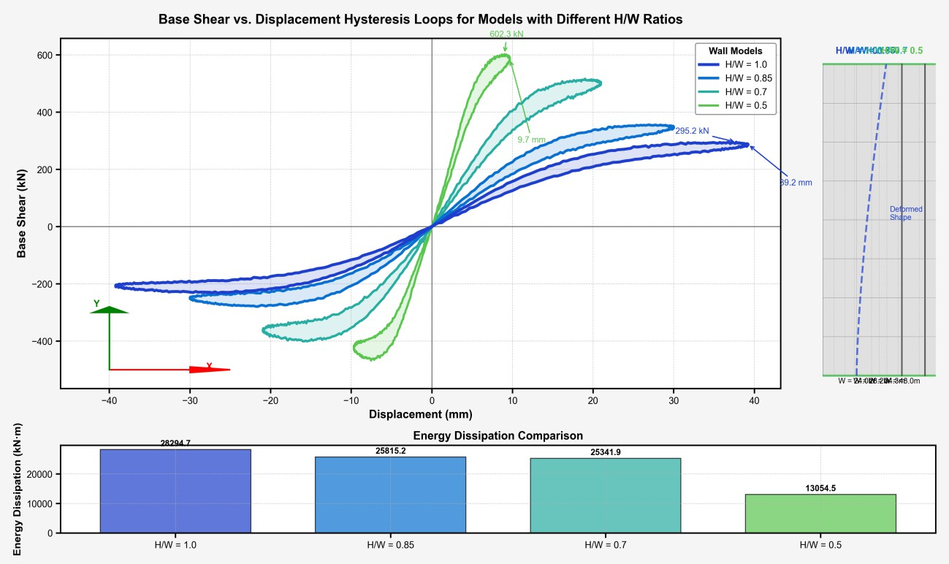
Figure 2 Base shear vs. displacement hysteresis loops for models with different H/W ratios

Table 4 summarizes the energy dissipation values for all models. The energy dissipation consistently decreased with decreasing H/W ratio, with reductions of 33.28%, 54.54%, and 66.10% observed for models W02, W03, and W04 compared to W01, respectively. This inverse relationship between wall width and energy dissipation highlights the trade-off between stiffness and energy absorption capacity in seismic design.

Table 4 Energy dissipation results for all models

Stress distribution and damage patterns
Figure 3 presents stress contour plots for models with different H/W ratios at maximum displacement. For slender walls (H/W = 1.0), stress concentrations were primarily observed at the base corners, indicating a predominantly flexural response. As the H/W ratio decreased, stress patterns shifted to a more distributed configuration with diagonal stress bands, signifying increased shear contribution to the overall response.

Model Energy Dissipation (kN·m) Model Energy Dissipation (kN·m)
W01 54.99 W013 59.04
W02 37.01 W014 39.03
W03 24.99 W015 28.97
W04 19.01 W016 23.96
W05 53.98 W017 55.99
W06 34.99 W018 38.05
W07 22.98 W019 27.02
W08 14.97 W020 17.00
W09 53.01 W021 58.00
W010 32.02 W022 34.01
W011 22.03 W023 18.07
W012 12.95 W024 16.02

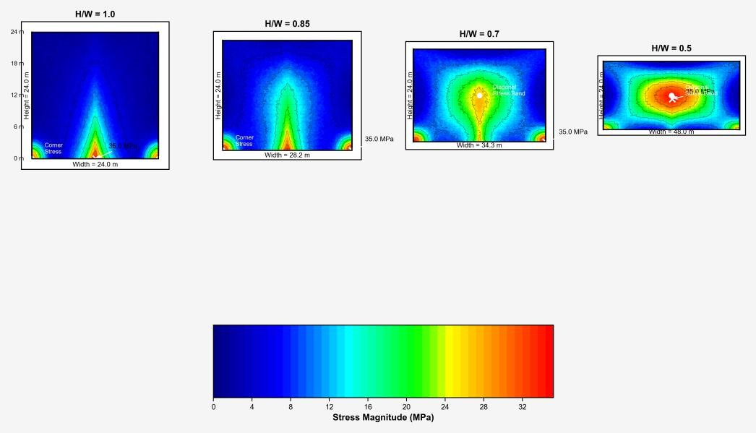
Figure 3 Stress contour plots showing damage concentration areas in walls with different H/W ratios

The concrete damage progression, visualized through cracking patterns (Figure 4), showed that walls with higher H/W ratios developed horizontal cracks near the base, consistent with flexural behavior. In contrast, walls with lower H/W ratios exhibited diagonal cracking patterns typical of shear-dominated response. These observations confirm the transition from flexural to combined flexural-shear behavior as the wall width increases.

Comparative analysis of nonlinear static and dynamic results
Table 5 compares the base shear and displacement results from NLTHA and pushover analysis. The results show good agreement between the two methods, with differences generally less than 10%. This validates the consistency of our analytical approach and confirms the reliability of the reported findings.

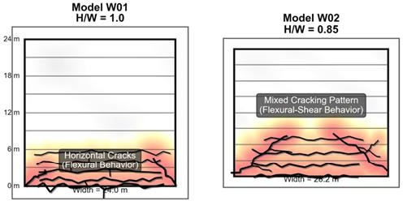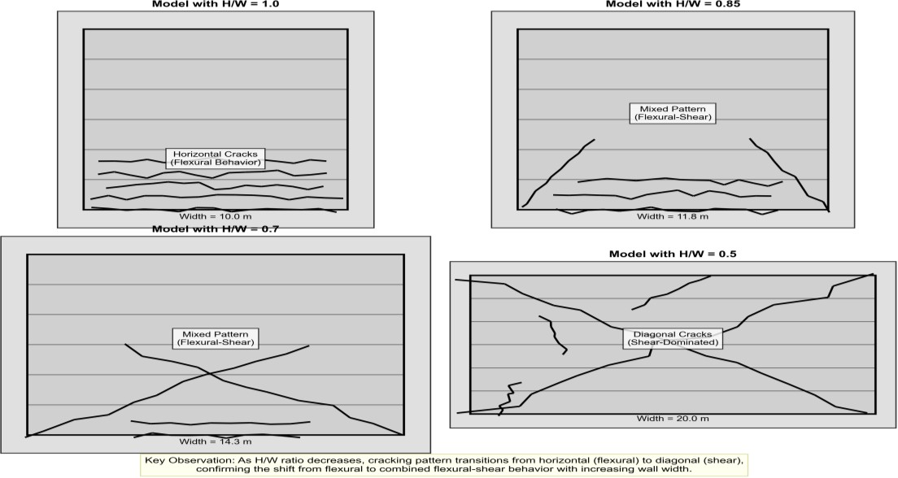
Figure 4 Damage patterns in walls with different H/W ratios at ultimate displacement
Table 5 Comparison of NLTHA and pushover analysis results for selected models
Model | Base Shear (kN) |  | Displacement (mm)
2-3 (lr)4-5 | NLTHA | Pushover | NLTHA | Pushover
W01 | 248.10 | 185.00 | -39.12 | -35.00
W04 | 508.57 | 500.00 | -9.67 | -8.50
W09 | 275.04 | 265.00 | -48.96 | -42.00
W012 | 623.54 | 602.00 | -20.00 | -15.00
W013 | 201.61 | 185.00 | -51.60 | -45.00
W016 | 499.35 | 485.00 | -9.02 | -8.20

Parametric effect analysis
Figure 5 presents a comprehensive analysis of how the three key parameters—wall width, concrete strength, and reinforcement ratio—affect energy dissipation, maximum displacement, and base shear
capacity. The figure demonstrates the relative influence of each parameter, with wall width showing the most significant impact on all performance metrics.

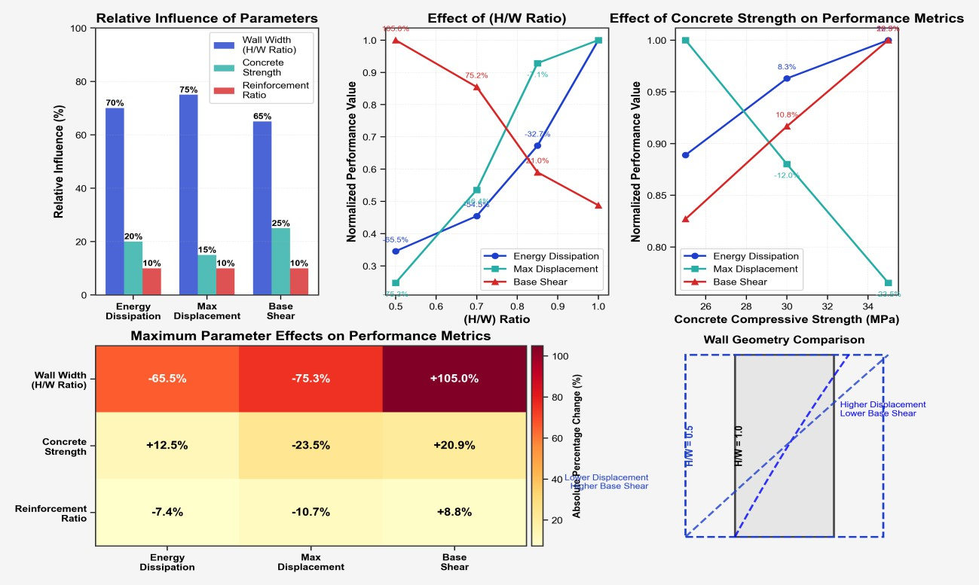
Figure 5 Relative influence of key parameters on seismic performance metrics

Discussion
Effects of wall geometry on seismic performance Our results demonstrate that wall geometry, specifically the H/W ratio, has the most profound impact on energy dissipation characteristics of RCSWs. As the H/W ratio decreased from 1.0 to 0.5, energy dissipation decreased by up to 66.10%, while base shear resistance increased by up to 104.97%. This inverse relationship can be attributed to the fundamental mechanics of lateral load resistance in walls.

Walls with higher H/W ratios (slenderer) exhibit predominantly flexural behavior, characterized by concentration of plastic deformation at the base. This leads to larger displacements and wider hysteresis loops, resulting in greater energy dissipation. In contrast, walls with lower H/W ratios (stockier) demonstrate combined flexural-shear behavior, with more distributed stress patterns and smaller displacements. These findings align with Bastami et al. [18] who observed similar behavior patterns in special RC shear walls under lateral cyclic loading.
The practical implication is that designers must carefully balance energy dissipation requirements against displacement limitations when selecting wall geometries. For buildings with stringent drift
limitations, stockier walls provide superior performance in controlling lateral displacements, albeit with reduced energy dissipation capacity.

Influence of material properties
Concrete compressive strength showed a significant but less pronounced effect on energy dissipation compared to wall geometry. Increasing compressive strength from 25 MPa to 35 MPa resulted in modest reductions in energy dissipation (1.83% to 19.78%) for equivalent geometries. This effect can be attributed to the increased stiffness associated with higher concrete strengths, which reduces displacements and consequently narrows hysteresis loops. The observed relationship between concrete strength and energy dissipation confirms findings by Akl and Ezzeldin [24], who reported similar trends in their hybrid simulation testing of two-storey nuclear RC shear walls. However, our results provide more granular quantification of this relationship across various wall geometries. From a design perspective, increasing concrete strength offers a balanced approach to enhancing seismic performance— providing moderate improvements in both strength and stiffness without drastically reducing energy dissipation capacity. This makes it a versatile parameter for optimization in practical applications.

Role of reinforcement configuration
Our analysis reveals that increased reinforcement ratios (achieved through reduced spacing from 2.0m to 1.5m c/c) resulted in reduced energy dissipation by 6.31% to 22.09% compared to models with lower reinforcement. This finding aligns with the observations of Ghaseminia et al. [19], who reported that double-layer reinforcement configurations, while enhancing strength and stiffness, can alter energy dissipation characteristics. The mechanism behind this relationship involves the contribution of reinforcement to overall wall stiffness and its effect on crack development. Higher reinforcement ratios delay and distribute cracking, resulting in smaller crack widths and reduced plastic deformation. While this improves damage control, it reduces the wall’s ability to dissipate energy through inelastic
deformation. These results highlight an important design consideration: reinforcement optimization should not focus solely on strength criteria but must also account for energy dissipation requirements in seismic design. Balanced reinforcement configurations that provide adequate strength while maintaining sufficient deformation capacity are essential for optimal seismic performance.

Comparative analysis with previous studies
Table 6 compares our key findings with recent studies on RC shear wall behavior under seismic loading. Our results generally align with previous research while providing more comprehensive parametric relationships, particularly regarding the interaction between multiple design variables.

Table 6 Comparison with previous studies
Study Focus Area Comparison with current findings

[2] Cyclic and axial loading
Similar trends in H/W ratio effects, but our study provides more granular quantification across parameters

[3] | Reinforcement layers | Confirms reduced energy dissipation with increased reinforcement, with our study adding  quantitative relationships
[7] | Economic assessment | Similar findings on strength benefits, our study adds detailed energy dissipation metrics
[13] | Hybrid reinforcement | Confirms material property effects, while our study offers more comprehensive parameter  interactions

Study limitations
While this research provides valuable insights into energy dissipation mechanisms, several limitations should be acknowledged:
  - Idealized boundary conditions: The models assumed idealized foundation conditions that may not fully represent soil-structure interaction effects in real buildings.
  - Limited parameter range: The study examined specific ranges of H/W ratios (0.5-1.0), concrete strengths (25-35 MPa), and reinforcement ratios, which may not encompass all practical design scenarios.
  - Ground motion selection: While the analysis used appropriately scaled ground motions, a more extensive suite of records could provide greater confidence in the statistical significance of the observed trends.
  - Scale effects: The models did not address potential scale effects that might influence the behavior of full-scale structural walls.
  - Computational constraints: Due to computational limitations, the maximum analysis duration was limited to 12.5 seconds, which may not capture the complete response under long- duration seismic events.

These limitations present opportunities for future research to expand on our findings and provide even more comprehensive design guidance. A complete list of abbreviations is listed in Appendix I.

Conclusion and future work
This study investigated the energy dissipation mechanisms in RC shear walls under seismic loading through comprehensive finite element analysis of 24 RCSW models with varied design parameters. Our findings offer several important conclusions:
- Wall Geometry Effects: Wall aspect ratio (H/W) emerged as the most influential parameter affecting seismic performance. Decreasing the H/W ratio from 1.0 to 0.5 reduced energy dissipation by up to 66.10% while increasing base shear capacity by up to 104.97%. This inverse relationship represents a fundamental trade-off between energy dissipation and displacement control in seismic design.
- Concrete Strength Influence: Increasing concrete compressive strength from 25 MPa to 35 MPa enhanced stiffness and reduced displacements, with modest reductions in energy dissipation (1.83% to 19.78%). The improved modulus of

elasticity associated with higher strength concrete provides a balanced enhancement of both strength and stiffness properties.
- Reinforcement Configuration: Increased reinforcement ratios improved ductility but reduced energy dissipation by 6.31% to 22.09%, highlighting the need for balanced reinforcement design that considers both strength requirements and energy dissipation capacity.
- Failure Mechanisms: Walls with higher H/W ratios exhibited predominantly flexural behavior with horizontal cracking patterns, while lower H/W ratio walls demonstrated combined flexural- shear response with diagonal stress distributions. This transition in failure mechanism significantly influences energy dissipation characteristics.
- Analysis Method Validation: Good agreement between NLTH and pushover analysis results (differences <10%) validates the reliability of our analytical approach and confirms the robustness of the observed parametric relationships.
These findings provide valuable quantitative relationships between design parameters and seismic performance metrics, offering practical guidance for optimizing RCSW designs in seismic regions. The demonstrated trade-offs between energy dissipation, strength, and displacement control emphasize the importance of performance-based approaches in seismic design.

Building on the current findings, several promising directions for future research are identified:
- Development of more sophisticated FEM models incorporating detailed soil-structure interaction, strain rate effects, and bond-slip behavior could enhance prediction accuracy.
- Investigation of innovative hybrid systems combining RC shear walls with energy dissipation devices could offer optimal solutions balancing strength, stiffness, and energy dissipation requirements.
- Exploration of high-performance concrete, fiber- reinforced composites, and advanced reinforcement systems could expand the design space for optimizing seismic performance.
- Translation of these parametric relationships into simplified design equations and procedures could facilitate practical implementation in seismic design codes.
- Integration of sustainability metrics into seismic performance optimization could lead to more holistic design approaches addressing both safety and environmental objectives.

These future research directions will continue to advance our understanding of energy dissipation mechanisms in RC structures and contribute to the development of more resilient buildings in seismic- prone regions.

Acknowledgment
None.
Conflicts of interest
The authors have no conflicts of interest to declare.

Data availability
None.

Author’s contribution statement
Yasir W. Abduljaleel: Abduljaleel conceived the study, designed the research methodology, supervised the project, and led the data analysis and interpretation. He also contributed significantly to writing and editing the manuscript. Ali S. Ali: Assisted in data analysis and visualization, software installation, data curation, and the technical validation of computational models. Zainab A. Mohammed: contributed to the literature review, data collection, and the initial drafting of the manuscript. She also participated in the editing process. All authors reviewed and approved the final version of the manuscript.
References
- AL-saedi MA, Yaghmaei-sabegh S. Seismic vulnerability assessment of regular and irregular reinforced concrete shear wall buildings using fragility curves. Iranian Journal of Science and Technology, Transactions of Civil Engineering. 2025; 49(1):39-57.
- Hosseini SM, Yekrangnia M, Shakiba M, Bazli M, Oskouei AV. Experimental study on seismic performance of squat RC shear walls reinforced with hybrid steel and GFRP rebars. Structures. 2024; 64:106487.
- Cheng Y, He H, Sun H, Li J. Seismic experiment and performance analysis on embedded optimized steel plate-reinforced concrete composite shear wall under multi-dimensional loading. Journal of Building Engineering. 2024; 98:111087.
- Uros M, Prevolnik S, Savor NM, Atalic J. Seismic performance assessment of an existing RC wall building with irregular geometry: a case-study of a hospital in Croatia. Applied sciences. 2020; 10(16):1- 36.
- Laissy MY. Investigation of shear walls openings on the performance of seismic loads for irregular reinforced concrete structures on sloped terrain. SCIREA Journal of Civil Engineering and Building Construction. 2023; 8(3):100-19.
- Alarcón C, López Á, Vielma JC. Performance of medium-rise buildings with reinforced concrete shear walls designed for high seismic hazard. Materials. 2023; 16(5):1-19.

- Li HN, Li RH, Li C, Wang DB. Development of hysteretic model with dynamic effect and deterioration for seismic-performance analysis of reinforced concrete structures. Journal of Structural Engineering. 2020; 146(10):04020215.
- Zhao J, Shen F, Si C, Sun Y, Yin L. Experimental investigation on seismic resistance of RC shear walls with CFRP bars in boundary elements. International Journal of Concrete Structures and Materials. 2020; 14(1):1-20.
- Shi C, Hu L, Wu HG, Zhang QL, Su K. Seismic performance assessment of reinforced concrete frame‐ shear wall structures in hydropower plants based on material damage. Advances in Civil Engineering. 2020; 2020(1):1-17.
- Okumus P, Basereh S. Simplified analytical models for evaluating retrofitted reinforced concrete shear walls. In proceedings of the 17th world conference on earthquake engineering, 17WCEE, Sendai, Japan 2020 (pp. 13-8).
- De AA, Pecce MR. The role of infill walls in the dynamic behavior and seismic upgrade of a reinforced concrete framed building. Frontiers in Built Environment. 2020; 6:1-14.
- Beedalah MH, Mohaisen SK. Performance of reinforced concrete building with shear wall under the effect of seismic loads. International Journal of Modern Engineering and Research Technology. 2021; 6(21):367-75.
- Gürbüz M, Kazaz İ. A numerical investigation on the limitations of design equations for steel plate shear walls. Teknik Dergi. 2022; 33(5):12677-708.
- Aljuboori M, Tabatabai H. An energy dissipating seismic connector for precast concrete shear walls. Buildings. 2022; 12(7):1-19.
- Zaji HJ, Mohaisen SK. Energy dissipation of lightweight reinforced concrete shear walls: nonlinear time history analysis. Al-Mansour Journal. 2022; 36(1):69-95.
- El-azizy OA, Ezzeldin M, El-dakhakhni W. Comparative analyses of reinforced masonry and reinforced concrete shear walls with different end configurations: seismic performance and economic assessment. Engineering Structures. 2023; 296:116852.
- Shrestha SG, Dhakal RP, Tripathi M, Chandramohan
R. Nonlinear analysis of reinforced concrete walls: static vs dynamic analysis. Canadian conference - pacific conference on earthquake engineering. 2023 (pp. 1483-95).
- Bastami M, Salehi M, Ghorbani M, Moghadam AS. Performance of special RC shear walls under lateral cyclic and axial loads. Engineering Structures. 2023; 295:116813.
- Ghaseminia SM, Zahra T, Thambiratnam DP, Thamboo J. Response of RC shear walls with single and double layers of reinforcements subjected to in- plane cyclic loading. Structures. 2023; 56:1-17.
- Gürbüz M, Kazaz İ. Ultimate drift ratio prediction of
steel plate shear wall systems: a machine learning
approach. Challenge Journal of Structural Mechanics. 2024; 10(2):34-46.
- Kazaz İ, Sertkaya M, Yakut A. Effect of wall size on the rotation capacity of reinforced concrete structural walls. Journal of Structural Engineering. 2024; 150(4):04024016.
- Meghdadian M, Masoodi AR, Ghalehnovi M. Experimental study to unraveling the seismic behavior of CFRP retrofitting composite coupled shear walls for enhanced resilience. Composites Part C: Open Access. 2024; 15:100523.
- Abdoos H, Khaloo AR. Failure mechanism of a curved RC shear wall subjected to cyclic loading: Experimental findings. Engineering Structures. 2024; 304:117703.
- Akl A, Ezzeldin M. Hybrid simulation testing of two- storey low-aspect-ratio nuclear RC shear walls with normal-and high-strength reinforcement: seismic performance evaluation and economic assessment. Structures. 2024; 69:1-16.
- Chen X, Yan G, Hosseinzadeh H. Topology optimization of the flat steel shear wall based on the volume constraint and strain energy assumptions under the seismic loading conditions. Scientific Reports. 2024; 14(1):1-25.
- Sotiropoulos S, Lagaros ND. Topology optimization of framed structures using SAP2000. Procedia Manufacturing. 2020; 44:68-75.
- Al-jassim SA, Raheem HA. Seismic analysis of reinforced concrete buildings in south of Iraq based on different codes. International Journal of Engineering and Technology. 2018; 7(4.20):51-8.
- https://www.asce.org/publications-and-news/asce-7.
Accessed 20 July 2025.
- Sebahire F, Nsanzimfura T, Imanaturikumwe C, Hafashimana F. Comparative study of a reinforced concrete frame design based on American concrete institute (ACI-318) and British standards (EN 1992). Discover Civil Engineering. 2025; 2(1):1-11.

Yasir W. Abduljaleel, holds an M.Sc. in Structural Engineering and serves as a Lecturer in the Department of Civil Engineering, Faculty of Engineering, Al-Iraqia University, Baghdad, Iraq. He actively contributes to both teaching and research in the field of structural engineering.
Email: yasir.wisam@aliraqia.edu.iq


Ali S. Ali, holds an M.Sc. in Structural Engineering and is a Lecturer in the Department of Civil Engineering, Faculty of Engineering, Al-Iraqia University, Baghdad, Iraq. He is actively engaged in teaching and research in the field of structural engineering.
Email: ali.s.ali@aliraqia.edu.iq


Zainab A. Mohammed, holds an M.Sc. in Structural Engineering and is a Lecturer in the Department of Civil Engineering, Faculty of Engineering, Al-Iraqia University, Baghdad, Iraq. He is actively involved in teaching and research in the field of structural engineering.
Email: ZainabA.Mohammed@aliraqia.edu.iq
Appendix I

S. No. Abbreviation Description
- ANOVA Analysis of Variance

- ACI American Concrete Institute

- ASCE American Society of Civil Engineers
- BRB Buckling Restrained Brace

- CFRP Carbon Fiber Reinforced Polymer
- CBO Colliding Bodies Optimization
- ECBO Enhanced Colliding Bodies
Optimization

- FEM Finite Element Method

- GFRP Glass Fiber Reinforced Polymer
- HSR High-Strength Reinforcement
- NLTH Nonlinear Time History

- RC Reinforced Concrete

- RCSW Reinforced Concrete Shear Wall

